NETWORK CABILING AND TOPOLOGIES

Lab-02

Computer Networks COSC-3201
Lab Instructor:
SIR Inzimam Shahid

Student Name | Muhammad Saad Ali
Student Roll # | DSAI241103089
Department | BSAI
Year/Section | 3B

Lab 2: Network Cabling and Topologies

Objective:
The objective of this lab is to introduce students to standard network cabling techniques and common network topologies. Students will learn the purpose of different cable types, how they are constructed, and how topologies define the structure of a network.

Introduction:
Cables are the physical medium through which data travels in wired networks. Understanding how cables are designed and when each type is used is essential for building reliable networks. In addition, network topology refers to the arrangement of devices and the physical or logical structure of a network. Both cabling and topology are foundational concepts for anyone entering the field of networking.

Types of Network Cables:

- Straight-Through Cable:
This cable is commonly used to connect different types of devices, such as a computer to a switch or a switch to a router. The wiring sequence on both ends is the same, usually following the T568B standard.

- Crossover Cable:
This cable is used to connect similar devices directly, such as PC to PC or switch to switch. The wiring sequence differs on each end (T568A on one end and T568B on the other).

- Fiber Optic Cable (Overview):
Fiber optic cables transmit data using light pulses, offering high speed and long-distance communication. Although not typically made in lab environments, students should understand its purpose and advantages.

Cable Making Process (If Physical Lab Is Available):
Students will identify cable types, cut the cable, align wires according to the selected standard, and attach RJ-45 connectors using a crimping tool. The final cable will be tested with a cable tester to ensure proper connectivity.

Network Topologies:

- Bus Topology:
All devices share a single communication line. It is simple but prone to collisions and failures.

- Star Topology:
All devices connect to a central device such as a switch. It is reliable and easy to troubleshoot.

- Ring Topology:
Devices are connected in a circular manner. Data travels in one direction around the ring.

- Mesh Topology:
Each device connects to multiple devices, providing redundancy and high reliability.

Lab Activities:

- Identify straight-through and crossover cables.

- Straight-Through Cable:
This cable is commonly used to connect different types of devices, such as a computer to a switch or a switch to a router. The wiring sequence on both ends is the same, usually following the T568B standard.

- Crossover Cable:
This cable is used to connect similar devices directly, such as PC to PC or switch to switch. The wiring sequence differs on each end (T568A on one end and T568B on the other.
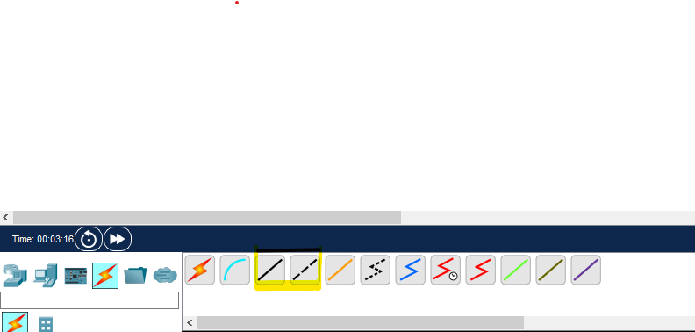
- create an Ethernet cable using the T568B standard (if equipment is available).
To make an Ethernet cable, use UTP cable, RJ-45 connectors, and a crimping tool. Strip the jacket, untwist and straighten the wires, then arrange them in T568B color order:White-Orange, Orange, White-Green, Blue, White-Blue, Green, White-Brown, Brown.Insert the wires into the RJ-45 connector, crimp firmly, and test with a cable tester.This creates a straight-through cable used for connections like PC to Switch or Switch to Router.
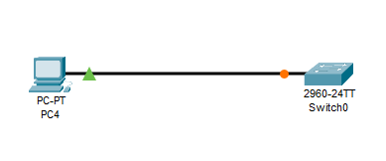

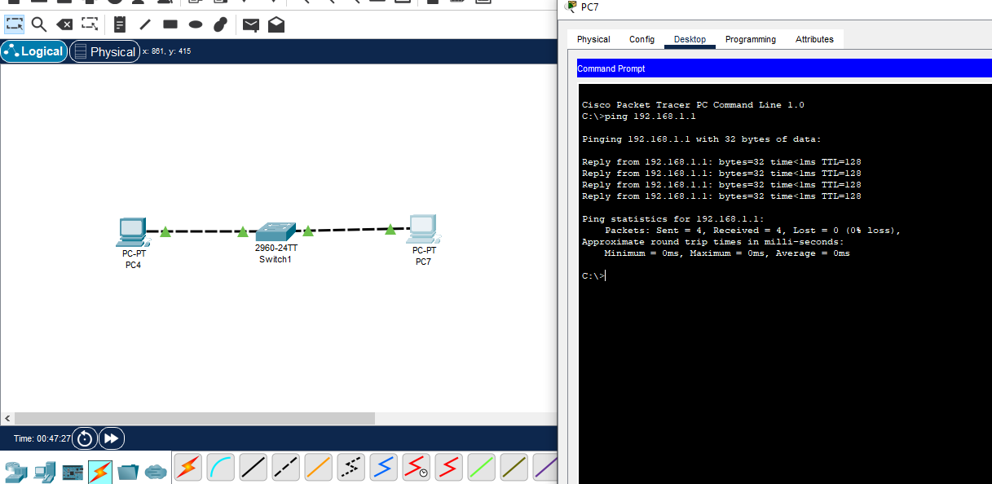
- Test a cable using a cable tester.
If you see “Reply from…” → ✅ Cable working
If you see “Request timed out” → ❌ Cable or IP problem
- Draw and label different network topologies.
ANS:
1.Bus Topology:
All devices share a single communication line. It is simple but prone to collisions and failures.
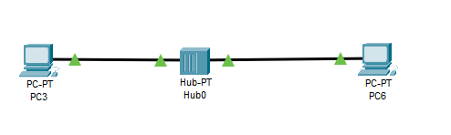
2.Star Topology:
All devices connect to a central device such as a switch. It is reliable and easy to troubleshoot.
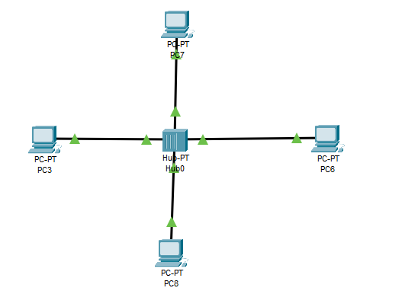

3.Ring Topology:
Devices are connected in a circular manner. Data travels in one direction around the ring.
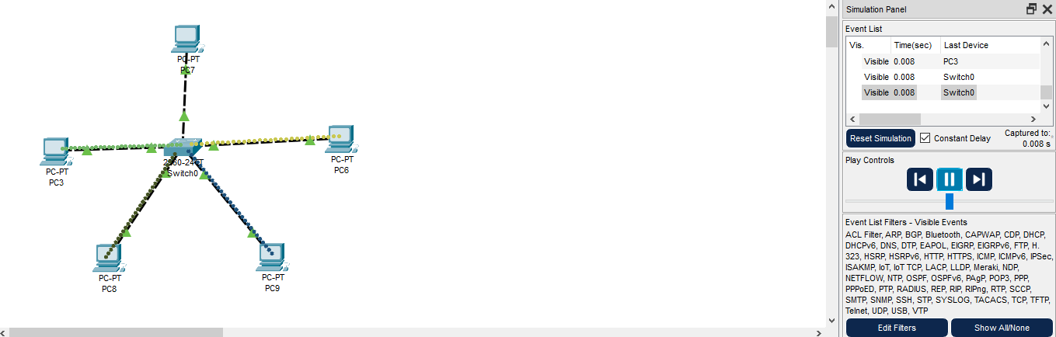

4.Mesh Topology:
Each device connects to multiple devices, providing redundancy and high reliability.

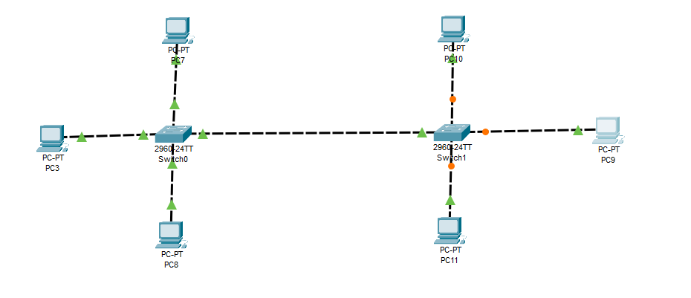
- Compare the advantages and disadvantages of each topology.
Topology | Advantages | Disadvantages
Bus | Simple, cost-effective, less cable | Backbone failure stops network, limited devices, hard to troubleshoot
Star | Easy management, single PC failure doesn’t affect network, scalable | Central device failure stops network, more cable, higher cost
Ring | Predictable data flow, good under heavy load | Single failure affects network, adding/removing devices interrupts network
Mesh | Highly reliable, multiple paths, secure | Expensive, complex, lots of cabling

Expected Outcomes:
By the end of this lab, students should be able to:
• Differentiate between straight-through and crossover cables.
• Construct a functioning Ethernet cable.
• Explain the purpose of physical and logical topologies.
• Identify and describe major network topologies.
• Select the appropriate cable and topology for a given networking scenario.

